DAVID LAWRENCE CENTERS
Overdose Prevention Handout
Please read, this information could save your life!
FACTS Regarding Overdose Prevention:
- Clients who have been actively using substances prior to admission are more at risk to die from an accidental overdose.

- Those who have been substance free since admission will have lower tolerance for substances than when they were admitted for treatment.

- If you choose to use substances when you are discharged, you can accidentally overdose, which could result in serious consequences, including death.

- If you choose to return to using substances in the same amount you were abusing prior to admission, the risk of accidental overdose is very high.

- We offer Medication Assisted Treatment for Opioid Use Disorder. We can offer Suboxone Maintenance or Naltrexone or Vivitrol. For Alcohol Use Disorder, we can provide Naltrexone or Vivitrol. Please call 239-354-1412 if you are interested in this life-saving treatment option.
Please, if you feel at risk to use, SEEK HELP. Call your sponsor, a family member and/or a sober friend. In addition, David Lawrence Centers is here to help. Our 24-hour DLC emergency services number is 239-354-1438.

FACTS Narcan/Naloxone Access and Usage:
ALWAYS CALL 911 IF THERE IS A SUSPECTED OVERDOSE
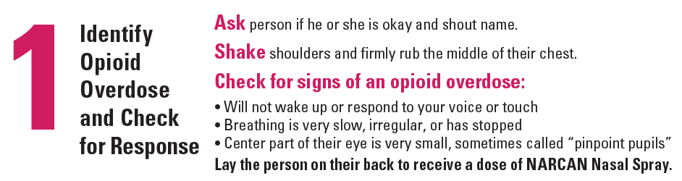
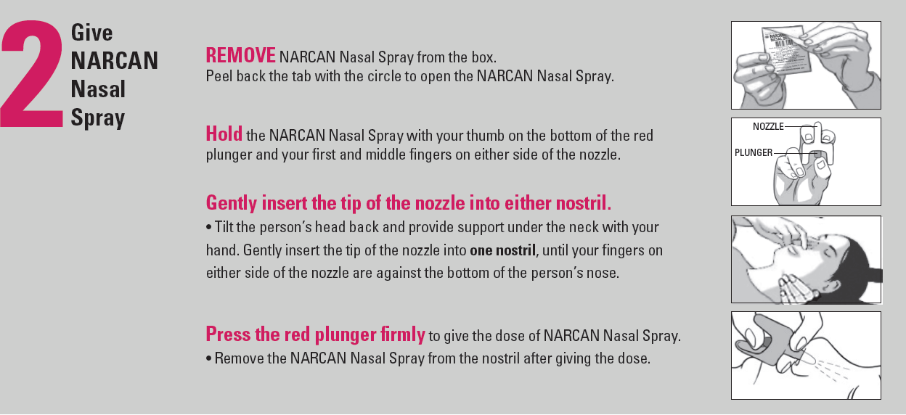
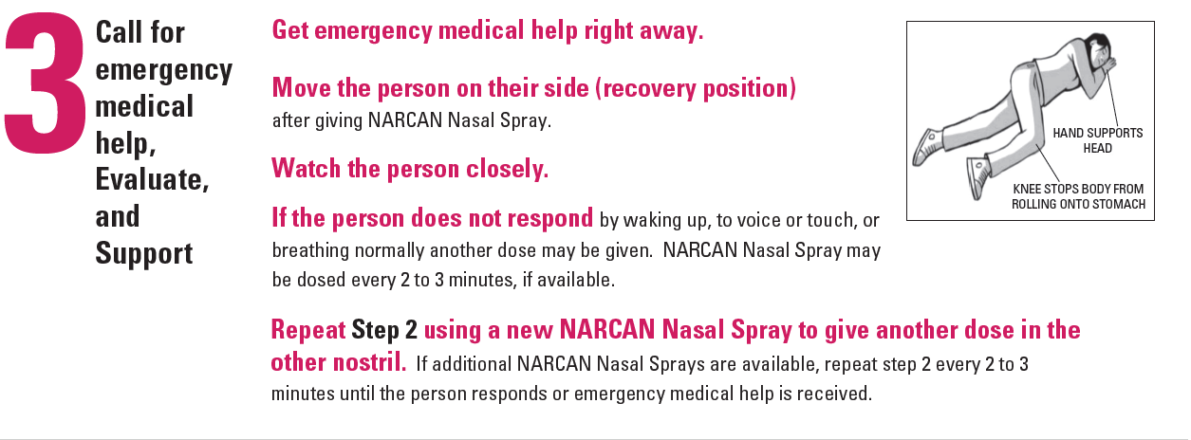

For information on how you can obtain a Naloxone/Narcan Nasal Spray kit today, you may contact David Lawrence Centers at 239-455-8500 ext. 1527 Or you may present to one of our centers listed below:

David Lawrence Centers:
6075 Bathey Lane, Naples, FL. 34116 (kits available 24/7 in building B3)
2806 S. Horseshoe Dr. Naples, FL 34104
425 N. 1st. St. Immokalee, FL. 34142

No personal information required
DLC Emergency Services is available 24/7 at 239-354-1438

You can also request a kit be mailed directly to you via email with the following email address HQW.SAMH@Myfamilies.com

If you use the Naloxone/Narcan Nasal Spray kit to reverse an overdose:
Please call the DLC Nurses Help Line at 239-304-3516 to report use of the kit, clients will receive a return call within 48 hours to assist with kit replacements (replacement kits are available 24/7 via DLC Emergency Services).

For additional Naloxone/Narcan related questions or additional information:

- www.narcannasalspray.com or call 1-844-4NARCAN (1-844-462-7226)
- https://isavefl.com/locator.shtml

REVISED: 1/6/21

