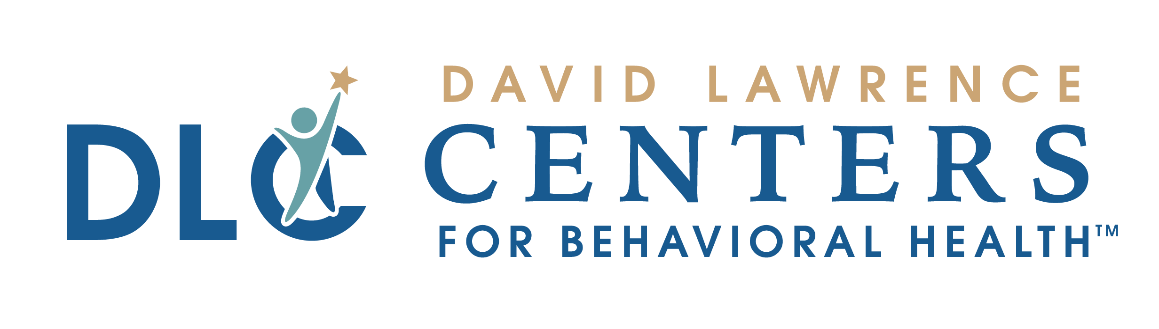
ACCESS CENTER
What to bring to your appointment

LOCATIONS
Individuals may access all David Lawrence Centers programs and services in Naples by contacting our Access Center at the David Lawrence Centers main campus off of Golden Gate Parkway located in Building B-1 at 6075 Bathey Lane.

Services for clients in Immokalee can be accessed by contacting the David Lawrence Centers Immokalee Satellite Services Center office located at 425 North First Street.

PLEASE BRING THE FOLLOWING ITEMS TO YOUR INITIAL VISIT:

- Any discharge paperwork or records that will be helpful to your assessing clinician
- Insurance card
- Payment for services
- If you do not have insurance, you may be eligible for a sliding fee scale discount.

In order to be evaluated for a discount, please provide sufficient proof of household income (proof of income for every person living in the household that receives any type of income). Per policy, we will need at least one of the below items for each household member:
- Tax Returns (A 1040 form. W2’s cannot be accepted.)
- Last three paystubs from each job in which you/household member is employed
- If you/household member receive unemployment, bring a letter stating how much you/ household member receives. If you applied but were denied, you can bring denial letter.
- If you/household member receive social security benefits, bring a letter stating how much you/household member receives.

MED-104 Advance Directives Education Handout Rev. 1/04, 3/08, 10/10

